**Download and install anaconda**

In order to work with python you will need to install it on your computer and set it up. There are lots of ways to do this, and lots of versions/distributions of python you could install. However, to make your life easier and to make sure we’re all on the same page, we strongly suggest that you download and install Anaconda.

Anaconda is a python distribution (don’t worry about what that means right now) that is geared towards data science and which comes with a lot of really useful tools for that purpose. To download Anaconda go to [anaconda.org](https://anaconda.org/) and click ‘Download Anaconda’ in the top bar.

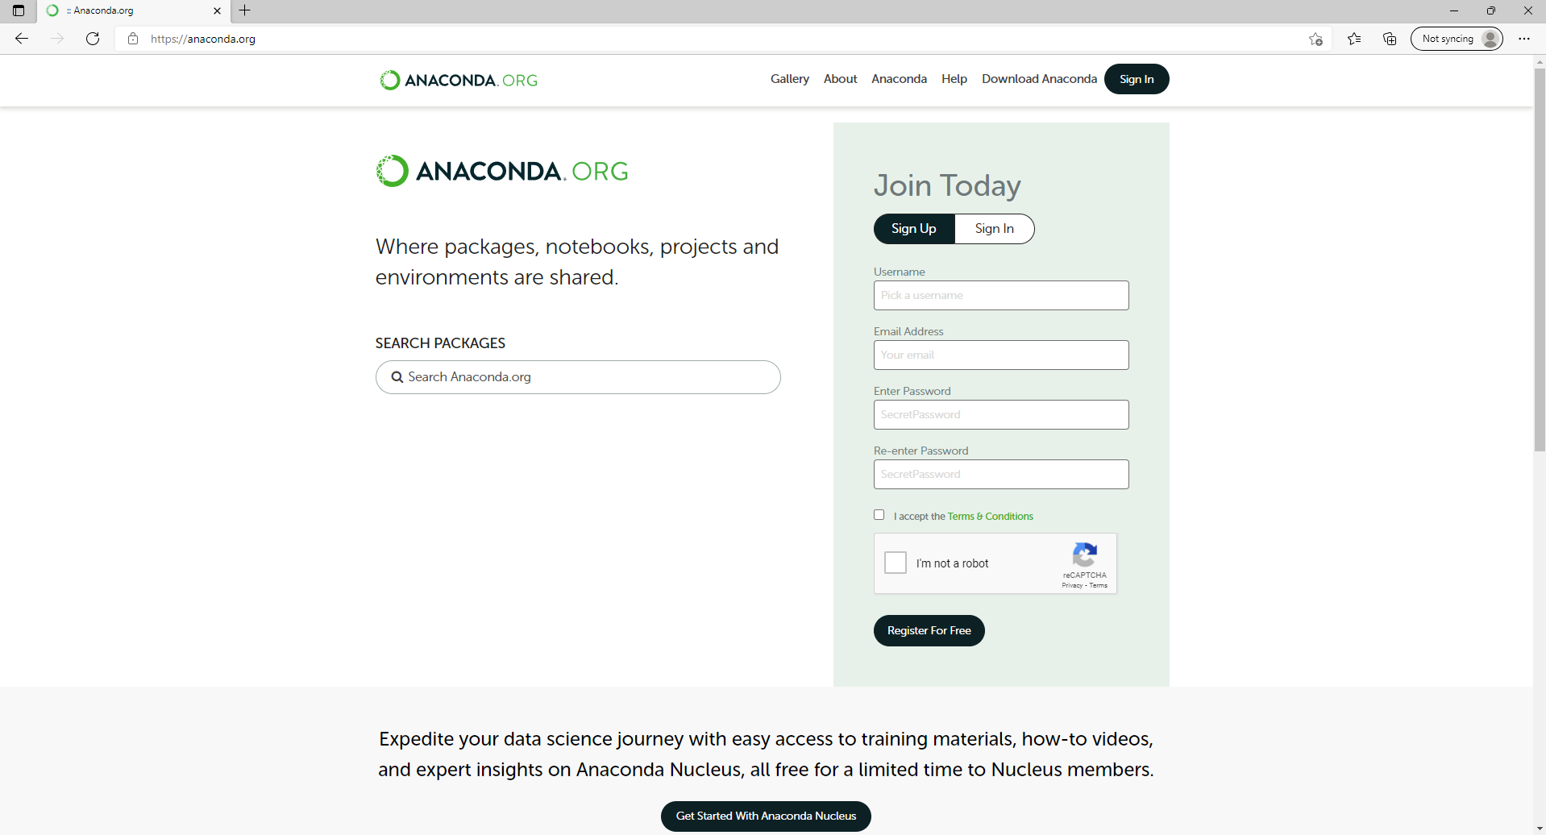

If you like, you can sign up for an Anaconda cloud account, but you really don’t need to and I recommend that you hold off on it until you have a better sense of what that means. The next page that comes up is the download page. It will most likely recognise your operating system (Windows, macOS or Linux) and so you can just click the green ‘Download’ button as shown below.

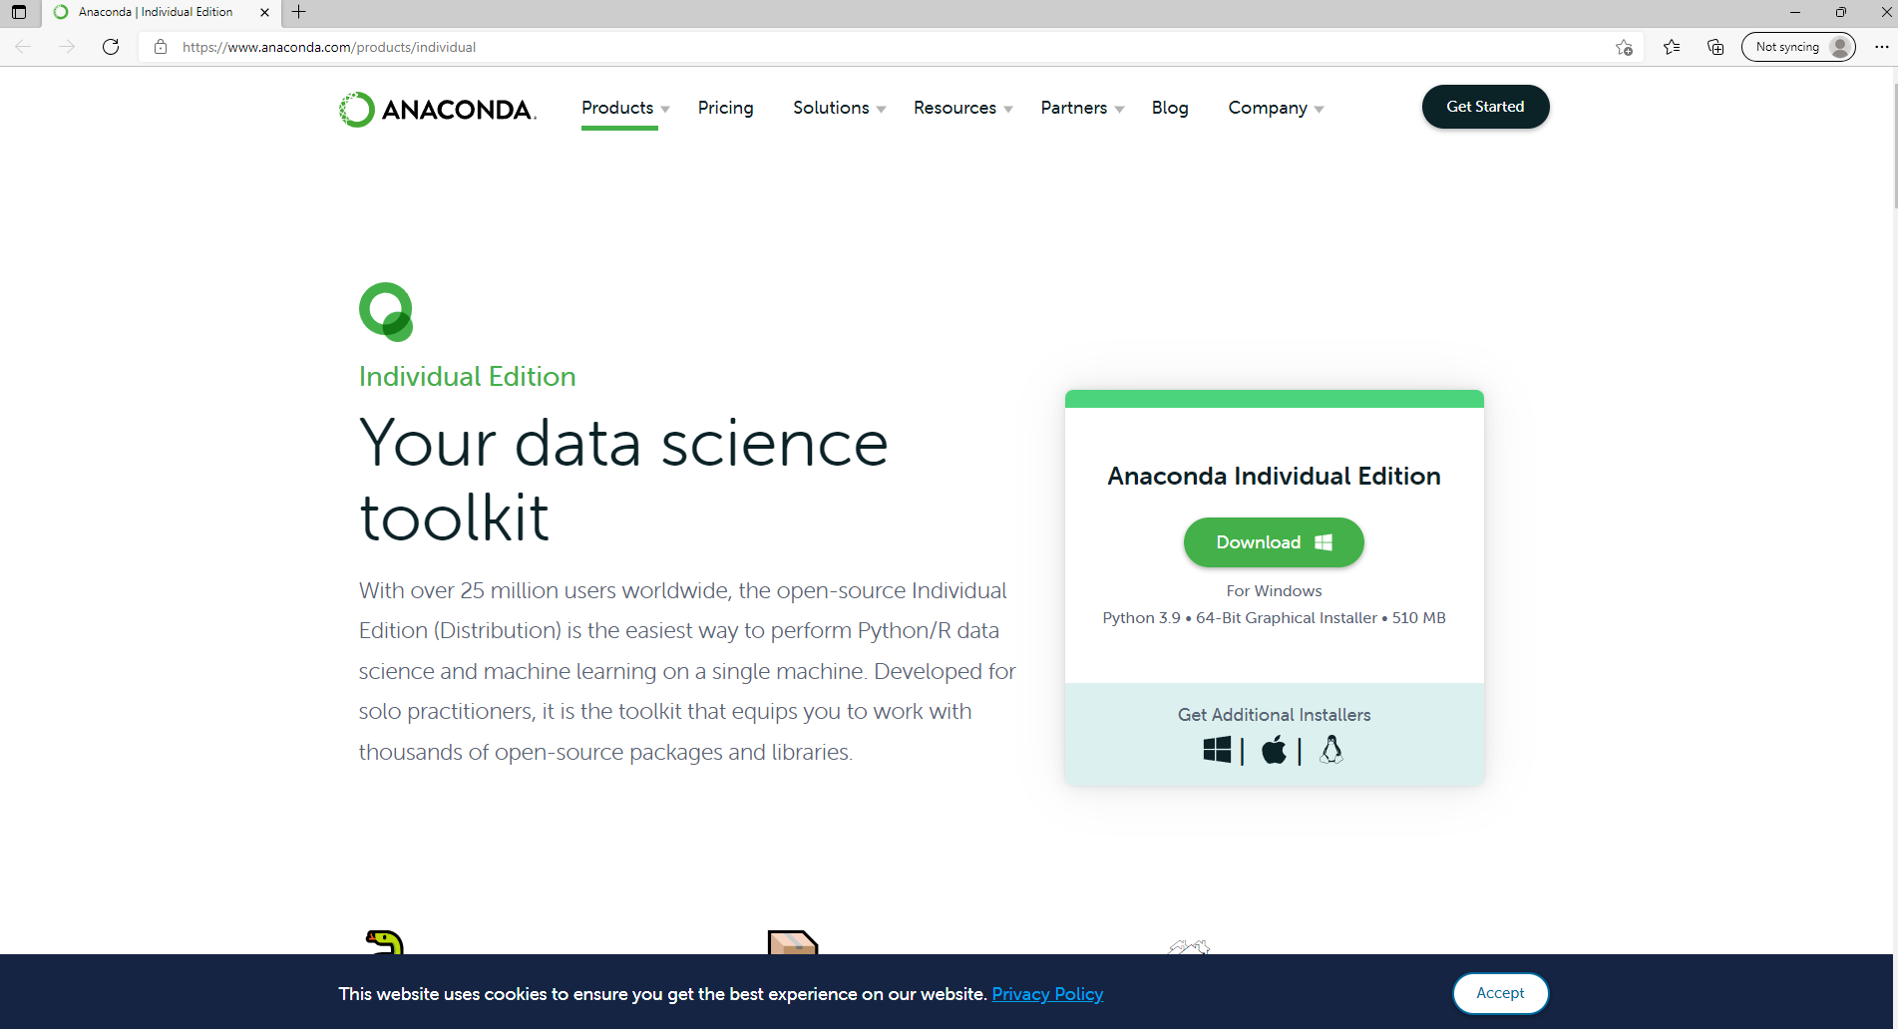

This will start the download (as circled in red) and also give you the opportunity to sign up to Anaconda Nucleus, again you don’t need to sign up to anaconda nucleus and I recommend that you don’t unless you have a good sense of what it is and what it’s for.

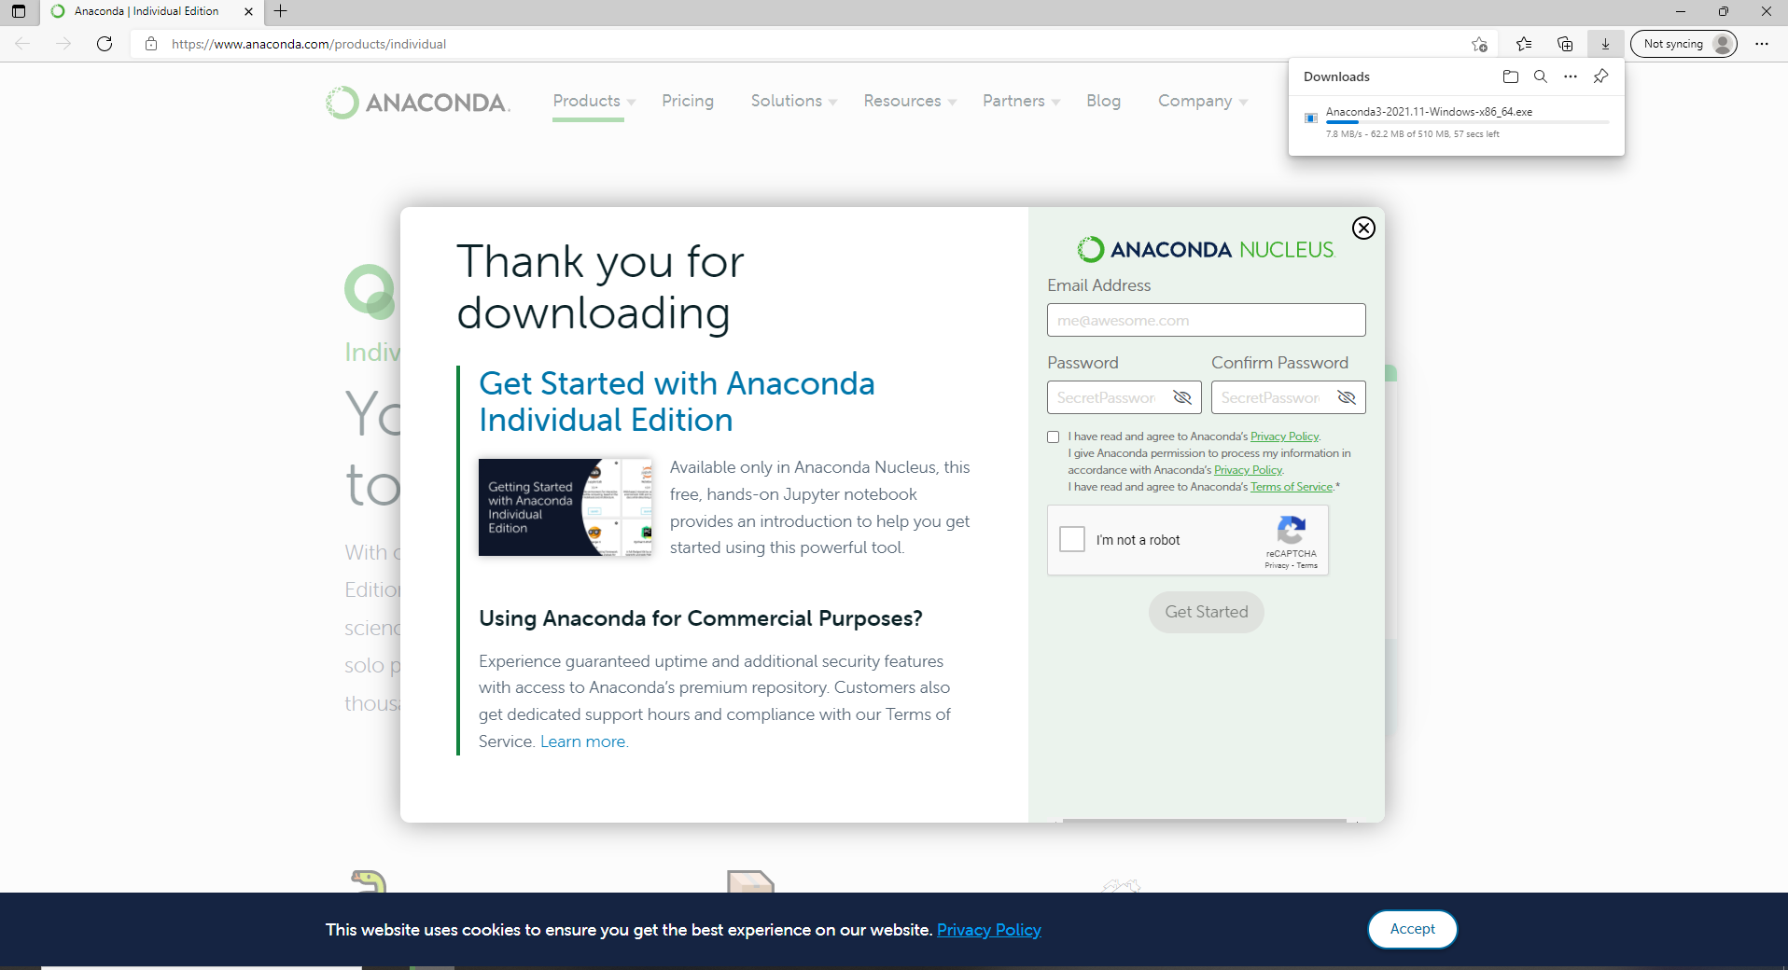

Once the download is finished you should be able just click ‘open file’ in your browser, or you may have to go into your ‘Downloads’ folder and look for the installer. This will be called ‘Anaconda3-2021.11-Windows-x86_64.exe’ on windows, or on a mac it’ll be something like ‘anaconda.dmg’. We will be using windows images in this guide, however the process is very similar on a mac (If you are running a Linux computer you don’t need this guide).

Once the installer is open it will present you with the screen below, this is just telling you what will happen during the install and recommends that you close other apps while installing. This is a good idea but it’s not vital (meaning that you can leave this guide open while you’re installing anaconda, but it would be a good idea to make sure that things like SPSS are closed).

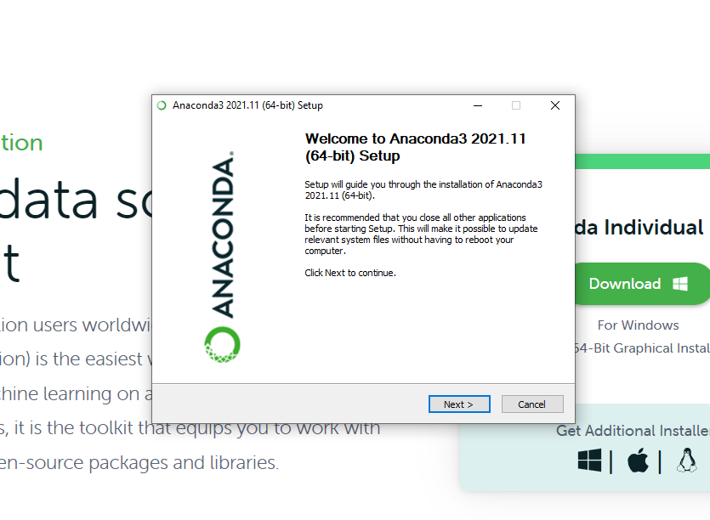

Next up is the licence agreement. If you are comfortable to install Anaconda you should give these a quick read and then click ‘I Agree’, which will move you onto the next screen.

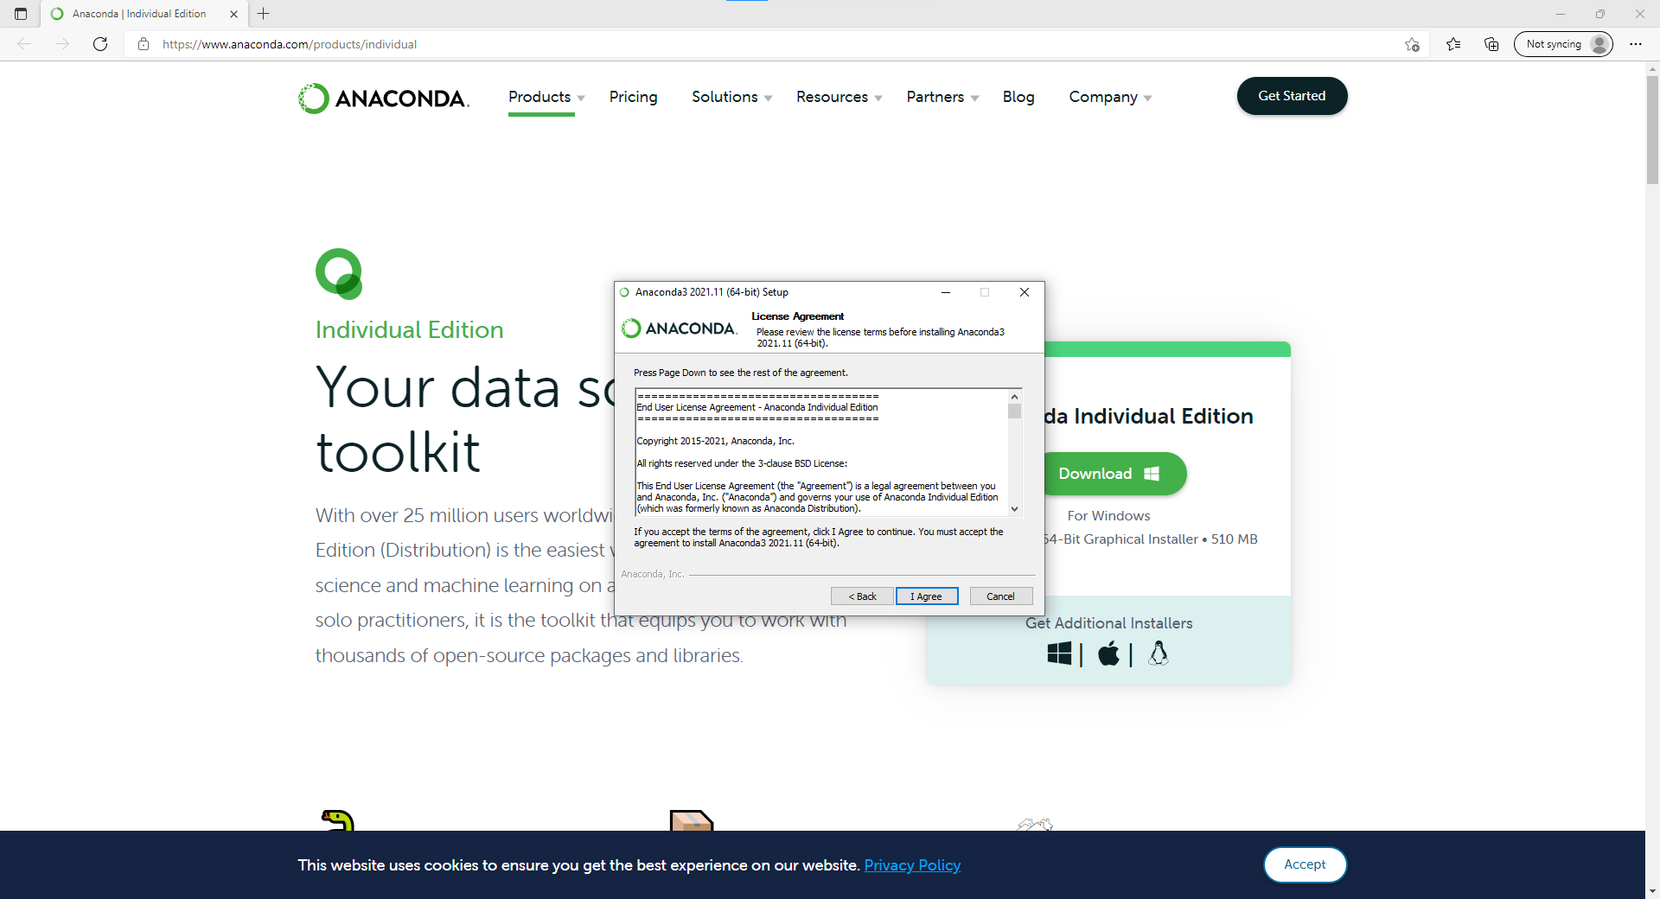

After this it’ll ask you if you want to install Anaconda for everyone who uses the device or just for this profile. Select ‘Just me’ (unless you have a good reason to select ‘All Users’) and then click next.

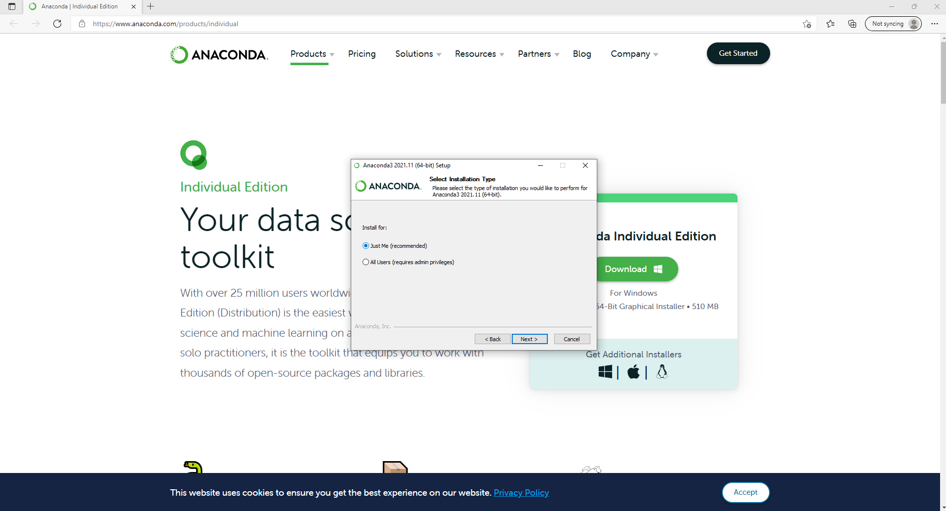

After this, you will be asked to select where to install Anaconda. Often this will be prepopulated with a folder on your computer, most likely in the ‘C://’ drive. You don’t need to change this, but you really should take note of where it is (maybe make a stiky note or something that contains the folder address). It’ll be something like ‘C:\Users\your_name\anaconda3’ if you’re on a windows device. Again, don’t change it just note where it is.

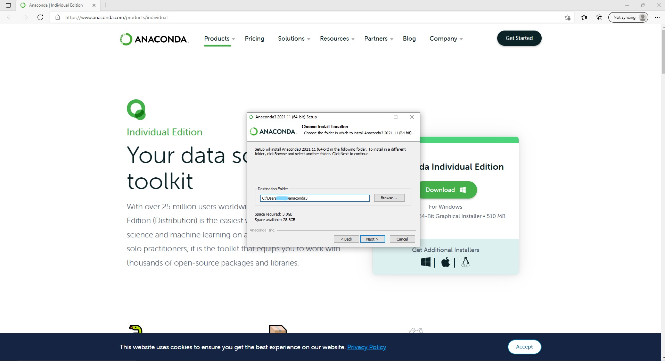

Then you will be asked if you want to add Anaconda3 to your PATH environment and if you want to register Anaconda3 as the default python 3.9. Make sure that the first tick box is **unchecked** (don’t add Anaconda3 to your PATH). Then make sure that the second tick box **is checked** (do make anaconda your default python). Once you’ve done this, just click ‘install’.

Do tick this one

Don’t tick this box

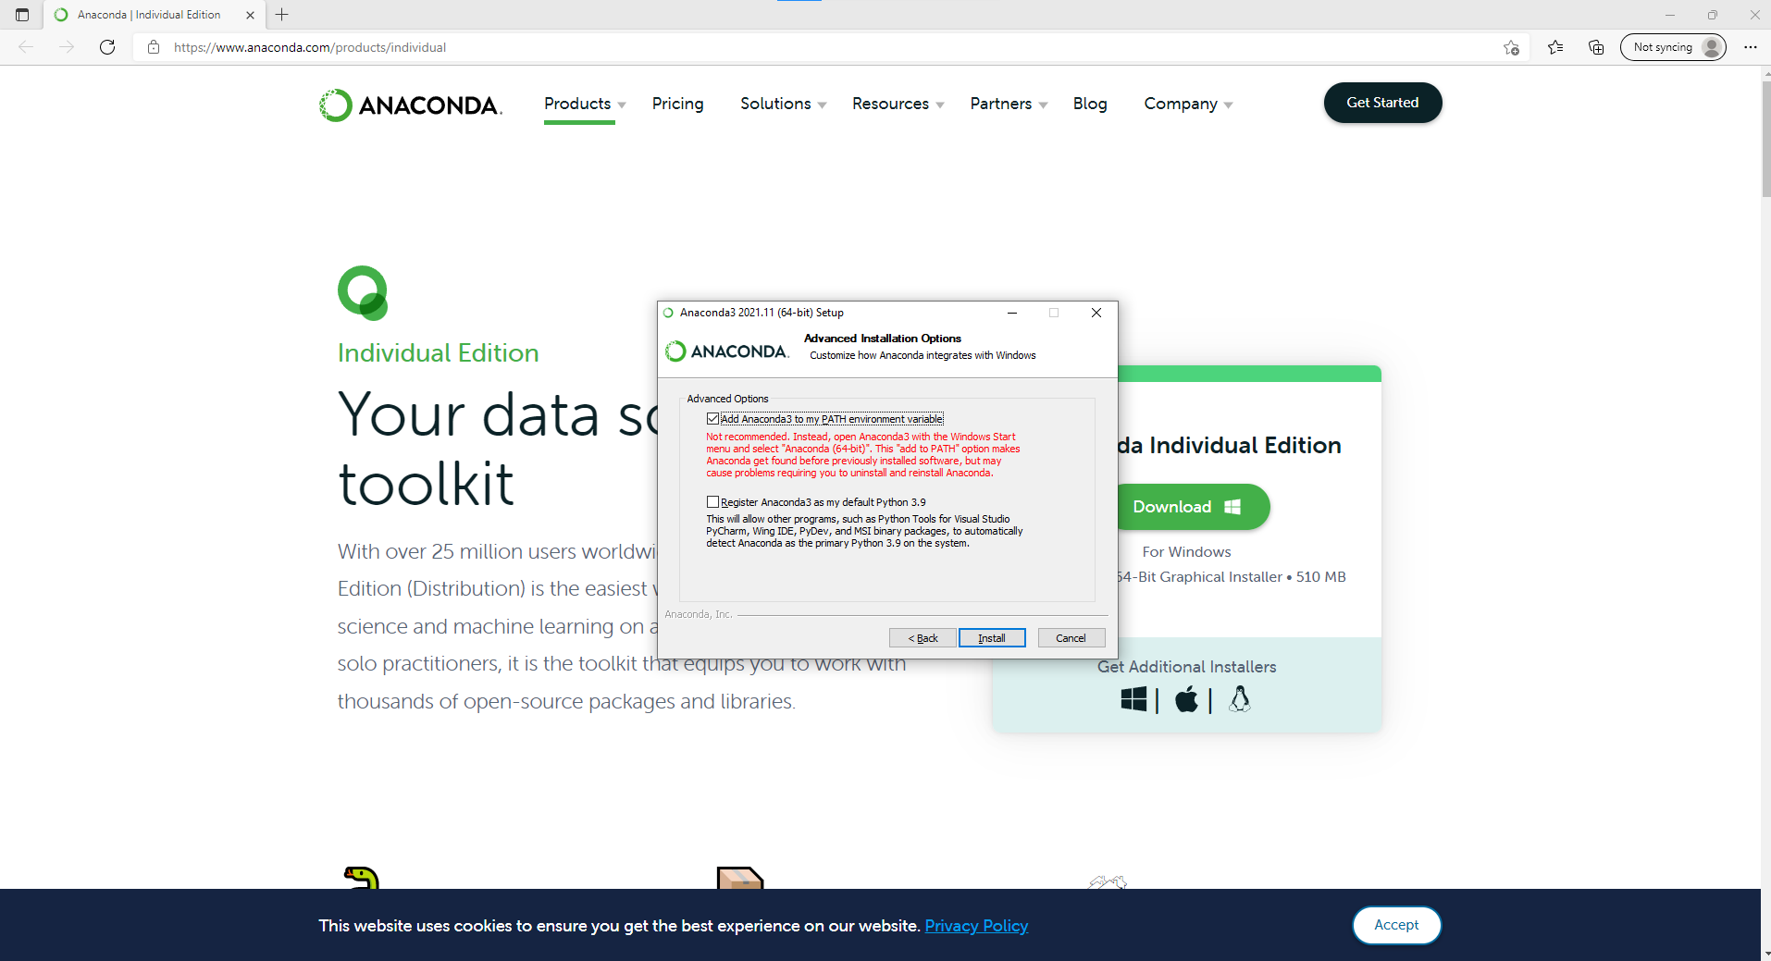

Then you’ll see the installation running, this takes a few minutes and it might stall once or twice so don’t panic.

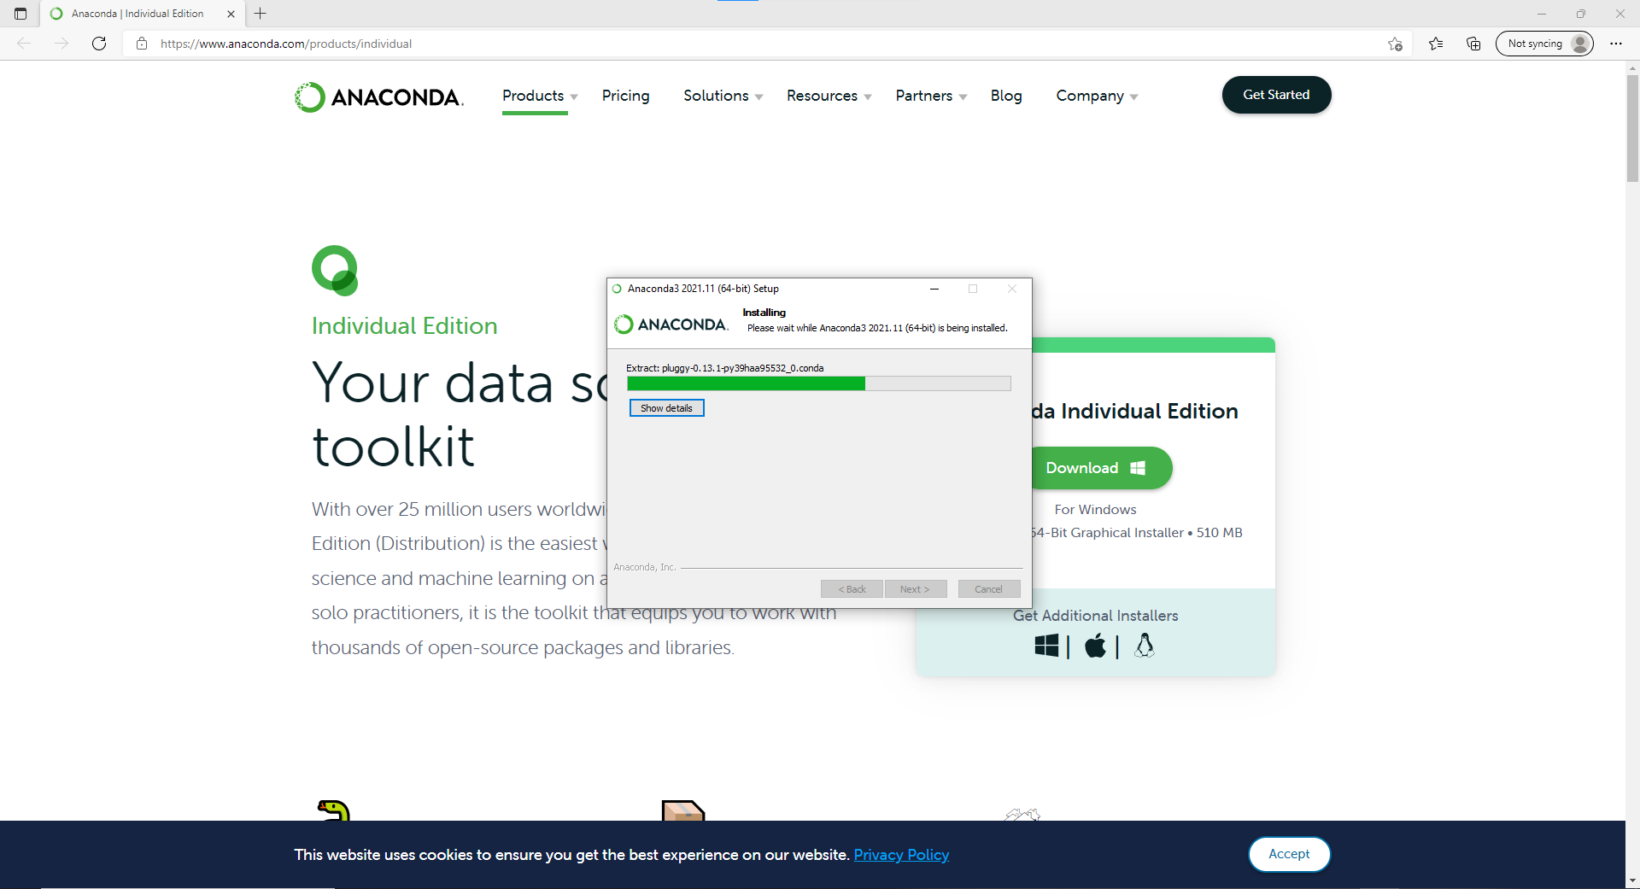

As part of this install you’ll be asked if you want to install ‘PyCharm’ which is a set of tools that are useful for more advanced datascience. I suggest you install these now, unless you are really running low on space on your device. Just click ‘Next >’

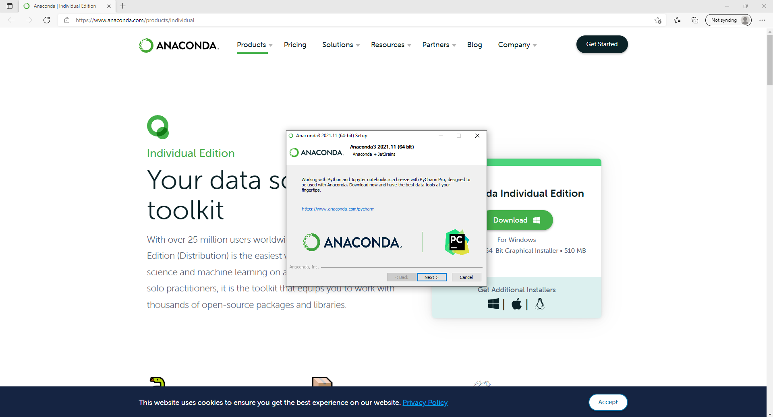

And boom, Anaconda is installed, just press ‘Finish’.

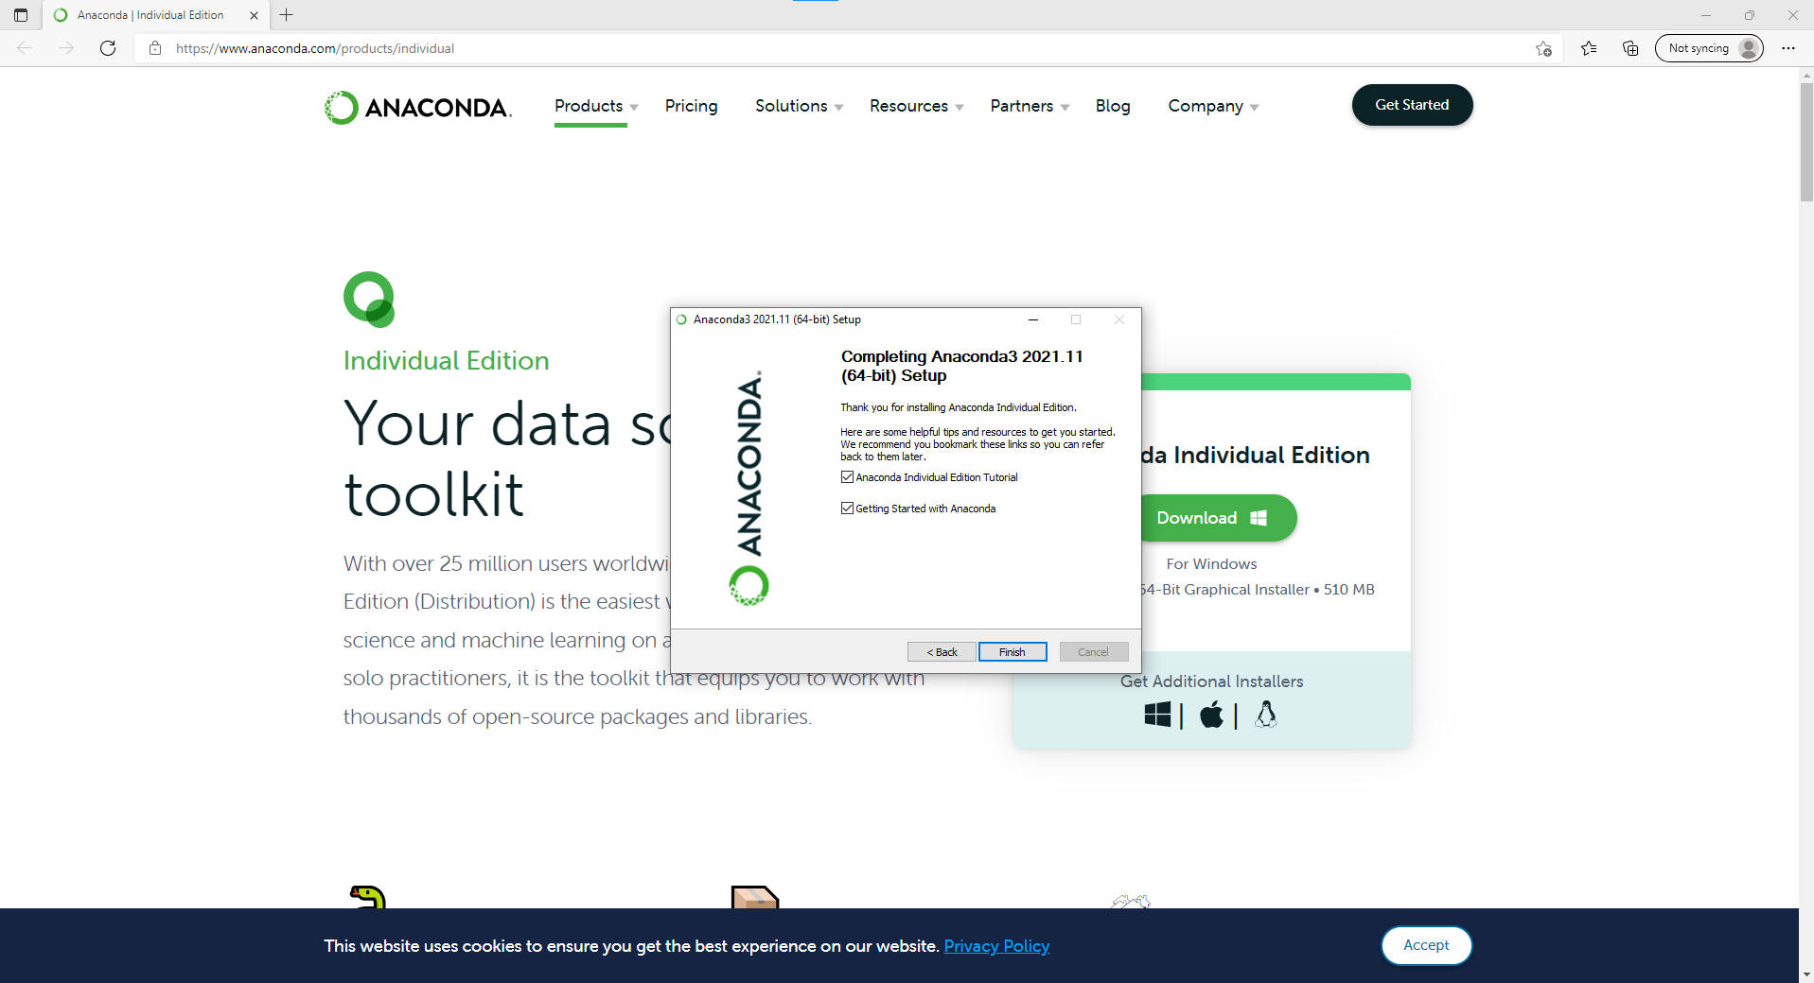

Once you come to the session we’ll help you open up visual studio code but if you want to you can open the ‘Anaconda Navigator’ to take a look at what’s going on in there, but honestly, it’ll be some time before you actually use the navigator.